# Deliverable-02

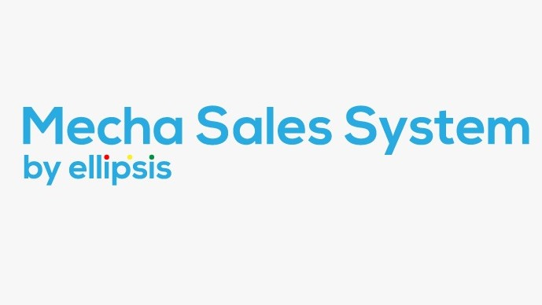

**Team Members:**

Adil Alam i170127 CS-E

Shaheer Hassan i170271 CS-E

Omar Ahmed i170040 CS-E

Table of Contents

**Modules 2**

**Sprint Backlog for First Iteration/Sprint:** **2**

**User Stories:** **2**

**Application Screenshots: 10**

**Test Cases: 22**

**Trello Screenshots: 28**

**Sprint plan: 31**

# **Module Names:**

# Employee Registration

* Inventory Management

## **Sprint Backlog for First Iteration/Sprint:**

|  |  |  |
| --- | --- | --- |
| User Stories | Priority | User Stories |
| Register Employee | 3 | 1 |
| Update Employee Details | 2 | 2 |
| Remove Employee Account | 1 | 3 |
| View Employee Details | 1 | 4 |
| Employee Login/Authentication | 2 | 5 |
| Add Electronic Robot | 1 | 6 |
| Update Electronic Robot Description | 2 | 7 |
| Remove Electronic robots | 1 | 8 |
| View electronic robots Details | 1 | 9 |
| Generate Inventory Report | 3 | 10 |

* **User Story ID 1:**

**Story Title:** Manage Employee

**Description:** As a manager, I want to manage employees so that I can keep record of the currently working employee’s information.

**Acceptance Criteria:** I know I am done with managing employees when:

|  |  |
| --- | --- |
| **Success**: | After being authenticated, I can manage employee’s information by pressing the widget “Register Employee”, “Edit Employee”, “View Employee”, and “Delete Employee”. |
| **Failure**: | Error message with “Error occurred” will be pop up. |

**Task:**

1. Register/Login Employee
2. Add Employee Details
3. Edit Employee Details
4. Ability to delete employee account.

* **Sub-User Story ID 1.1:**

**Story Title:** Register Employee

**Description:** As a manager, I want to register employees so that I can keep records of the employees and information related to them.

**Acceptance Criteria:** I know I am done with registering employees when:

|  |  |
| --- | --- |
| **Success**: | Valid Employee Information provided with the proper format, along with the “**Employee Registered”** message popped up after pressing the widget “**Register Employee”**. |
| **Failure**: | Error message with showing **“Invalid format”** will pop up. |

**Task:**

1. Create Database Table Name Employee
2. Create UI for registering employees
3. Write code to enter data in database
4. Integrate UI with code
5. Link Register Employee tab with managers tab.

* **Sub-User Story ID 1.2:**

**Story Title:** Update Employee Details

**Description:** As a manager, I want to update employees’ details like name, age, grade, etc, so that I can keep updated information on employees.

**Acceptance Criteria:** I know I am done with updating the details of employees when:

|  |  |
| --- | --- |
| **Success**: | **“Employee Details Updated”** message pops up after pressing **“Update”** |
| **Failure**: | **“Error Occurred”** message pops after pressing **“Update”**. |

**Task:**

1. Create UI for updating employee details information
2. Write code for updating employees’ information in database.
3. Link UI with code.
4. Link Update Employee tab with Managers tab.

* **Sub-User Story ID 1.3:**

**Story Title:** Remove Employee Account

**Description:** As a manager, I want to remove employees' accounts so that I can keep my system updated about current employees and employees that had left.

**Acceptance Criteria:** I know I am done with Deleting Employees Account when:

|  |  |
| --- | --- |
| **Success**: | “Employee Account Deleted” message pops up after pressing “Delete Account”. |
| **Failure**: | “Employee Account Deleted” message pops up after pressing “Delete Account”. |

**Task:**

1. Create UI for deleting employee account.
2. Write code to update employee state from current to left in database.
3. Link UI with code.
4. Link deleting employee account tab with managers tab.

* **Sub-User Story ID 1.4:**

**Story Title:** View Employee Details

**Description:** As a manager, I want to view employee details like name, age, grade so that I am able to know which employee is currently working and information related to them.

**Acceptance Criteria:** I know I am done with viewing employee details when:

|  |  |
| --- | --- |
| **Success**: | Valid User Information popped up. |
| **Failure**: | Invalid information or no information is popped up. |

**Task:**

1. Create UI for viewing employee’s details.
2. Write code to query employee’s information from database.
3. Link UI and code.
4. Link view employees’ detail tab with managers tab.

* **Sub-User Story ID 1.5:**

**Story Title:** Employee Login/Authentication

**Description:** As an employee, I want to login to the system so that I can access the system functions like make sales, generate a report, etc. to facilitate the customers.

**Acceptance Criteria:** I know I am done with authentication and get system accessories when:

|  |  |
| --- | --- |
| **Success**: | Valid User Information provided with the proper format, press login button, message with “Authenticated and prevailing Access” will pop up. |
| **Failure**: | Invalid User name error message pops up, or error message “Cannot Authenticated” pop up. |

**Tasks:**

1. Creating UI for authenticate an employee
2. Write code to authenticate employees name and password from database
3. Link UI with code
4. Link authenticate employee tab with employee tab.

* **User Story ID 2:**

**Story Title:** Manage Electronic Robots

**Description:** As an inventory manager, I want to manage electronic robots so that I can keep record of the currently present items in the stock.

**Acceptance Criteria:** I know I am done with managing employees when:

|  |  |
| --- | --- |
| **Success**: | After being authenticated as inventory manager, I can manage electronic robots information by pressing the widget “Add E Robot”, “Edit E Robot”, “View E Robot”, and “Delete E Robot”. |
| **Failure**: | Error message with “Error occurred” will be pop up. |

**Task:**

1. Add Electronic Robot.
2. Delete Electronic Robot Details.
3. Edit Electronic Robot Details.
4. Delete electronic robot.

* **Sub-User Story ID 2.1:**

**Story Title:** Add Electronic Robot

**Description:** As an Inventory Manager, I want to add electronic robots so that I can keep records of new electronic robots.

**Acceptance Criteria:** I know I am done with adding electronic robots when:

|  |  |
| --- | --- |
| **Success**: | “Electronic Robots Added” message pops up. |
| **Failure**: | “Error Occurred” message with details of the error pops up. |

**Task:**

1. Create Database Table Name “Electronic Robot”
2. Create UI for adding electronic robot.
3. Write code to add new electronic robot in database.
4. Link UI with code
5. Creating UI for Inventory Manager
6. Link adding new electronic robot tab with inventory manager tab.

* **Sub-User Story ID 2.2:**

**Story Title:** Update Electronic Robot Description

**Description:** As an inventory manager, I want to update the Electronic Robot description so that I can keep a record of Electronic Robots updated.

**Acceptance Criteria:** I know I am done with updating the description of Electronic Robot.

|  |  |
| --- | --- |
| **Success**: | Valid User Information provided with the proper format, and upon saving the new information, the “Electronic Robot Description Updated” message will pop up. |
| **Failure**: | In case of missing any required description like Robot-id an error message with “Electronic Robot Description Not Updated” will pop up. |

**Task:**

1. Create UI for updating Electronic Robot description.
2. Write code to update Electronic Robot description in database.
3. Link UI with code.
4. Link adding new electronic robot tab with inventory manager tab.

* **Sub-User Story ID 2.3:**

**Story Title:** Remove Electronic robots

**Description:** As an Inventory Manager, I want to remove unwanted or old electronic robots so that I can keep my system updated about current electronic robots.

**Acceptance Criteria:** I know I am done with removing electronic robots when:

|  |  |
| --- | --- |
| **Success**: | Upon deleting the description of the robot, the message with “Electronic Robots Details Deleted” will pop up. The entry of that robot description will also be deleted on that event. |
| **Failure**: | Upon entering invalid input format - Error message with “Cannot Delete electronic robots” will pop up. Alternatively, may pop up an error message with “electronic robots not found”. |

**Task:**

1. Create UI for deleting electronic robots.
2. Write code to deleting electronic robots in database.
3. Associate code for searching electronic robots description with UI for deleting electronic robots.
4. Link UI with code.
5. Link deleting electronic robots tab with inventory manager tab.

* **Sub-User Story ID 2.4:**

**Story Title:** View electronic robots Details

**Description:** As an Inventory Manager, I want to view electronic robot details like name, specifications, price, a quantity so that I am able to know which electronic robots are currently available and which features they have.

**Acceptance Criteria:** I know I am done with viewing electronic robots details when:

|  |  |
| --- | --- |
| **Success**: | Valid electronic robots Information provided with the proper format press View button, message with “electronic robots Details will pop up. |
| **Failure**: | Alternatively may pop up an error message with “Electronic robots not found”. |

**Task:**

1. Create UI for viewing electronic robots details.
2. Write code to view electronic robots details by getting information from database.
3. Link UI with code.
4. Link viewing electronic robots details tab with inventory manager tab.

* **User Story ID 3:**

**Story Title:** Generate Inventory Report

**Description:** As an Inventory Manager, I want to see the detailed inventory report which can be the quantities of all the robots in my inventory i.e. stock available, and which of the Robots are low in stocks so that I can see the stock of robots that are available using a report.

**Acceptance Criteria:** I know I am done with generating inventory reports:

|  |  |
| --- | --- |
| **Success**: | After pressing the “generating report” report cross-ponding to complete inventory will pop up. |
| **Failure**: | Error Message with text pop up “Error Occurred”. |

**Tasks:**

1. Creating UI for generating inventory report.
2. Write code to generate inventory report.
3. Link UI with code.
4. Link generate inventory report tab with inventory manager tab.

# **Sprint-1 Screen Shots**

## User Interface Screen Shot

Employee Authentication UI: 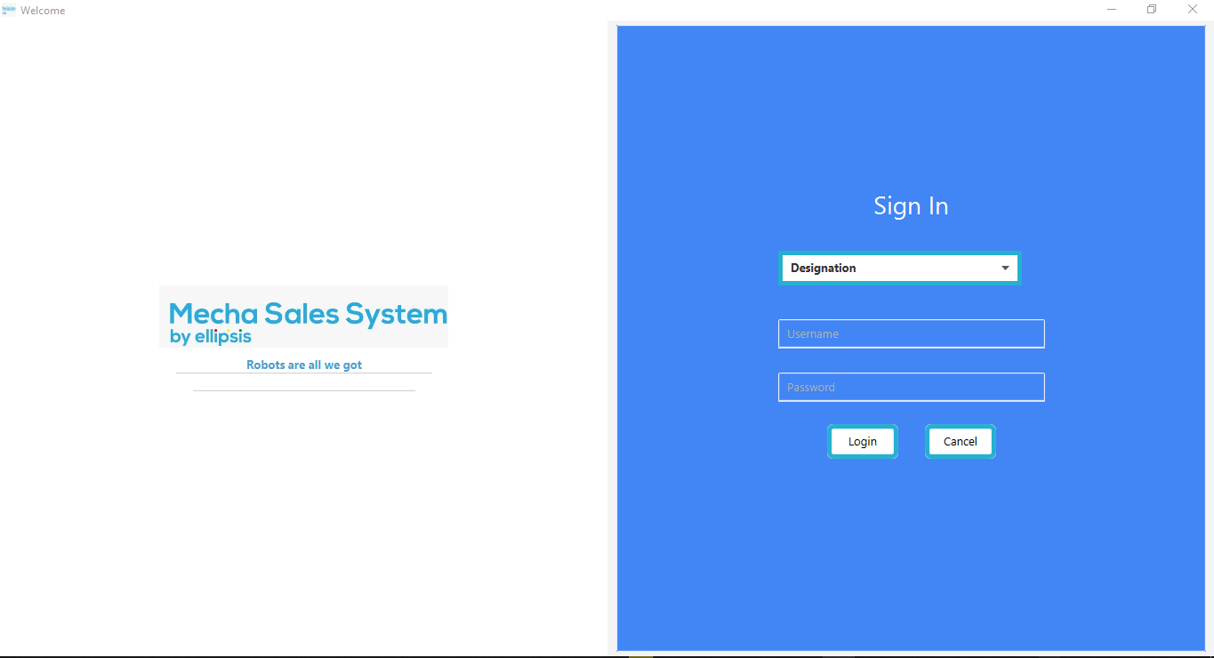

Manager Screen UI:

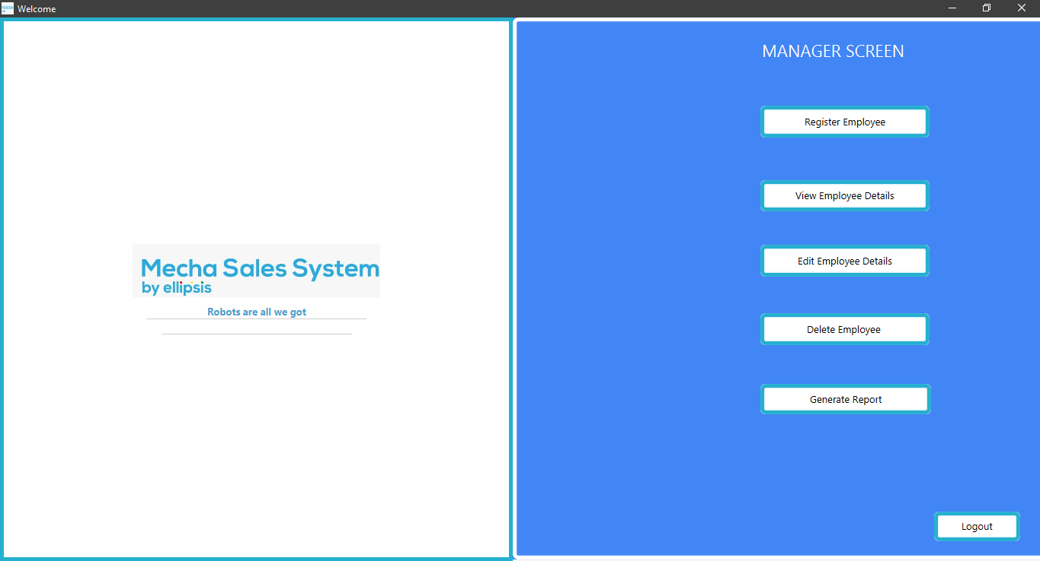

Register Employee UI:

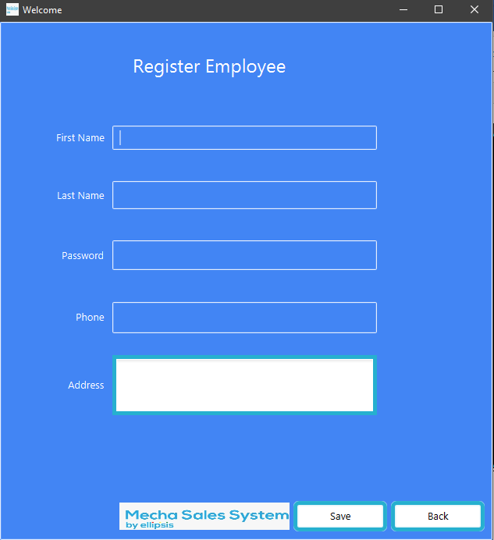

Update Employee Details UI:

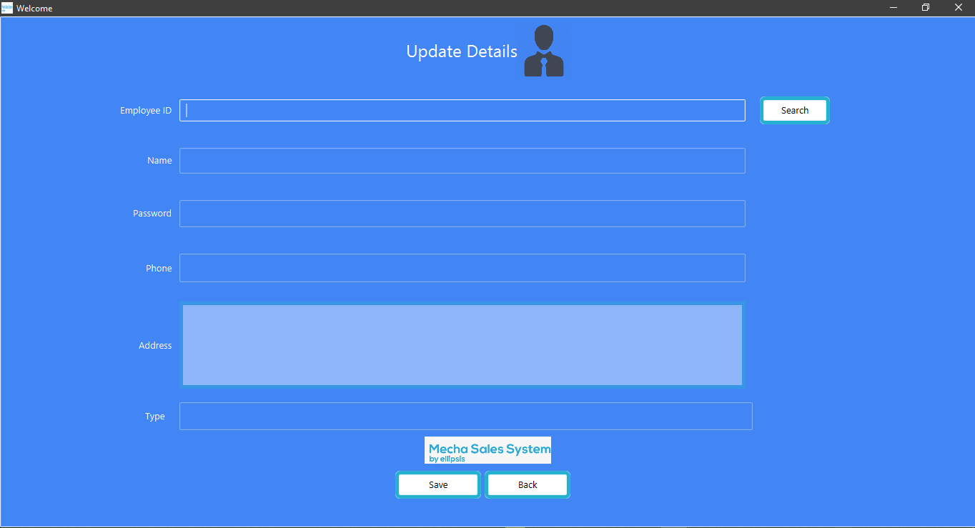

Delete Employee UI:

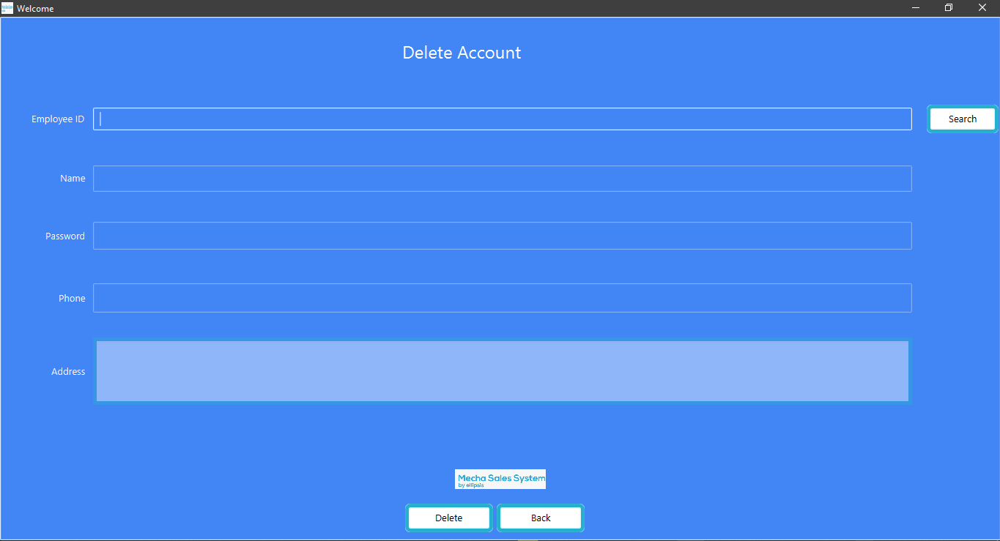

View Employee Details UI:

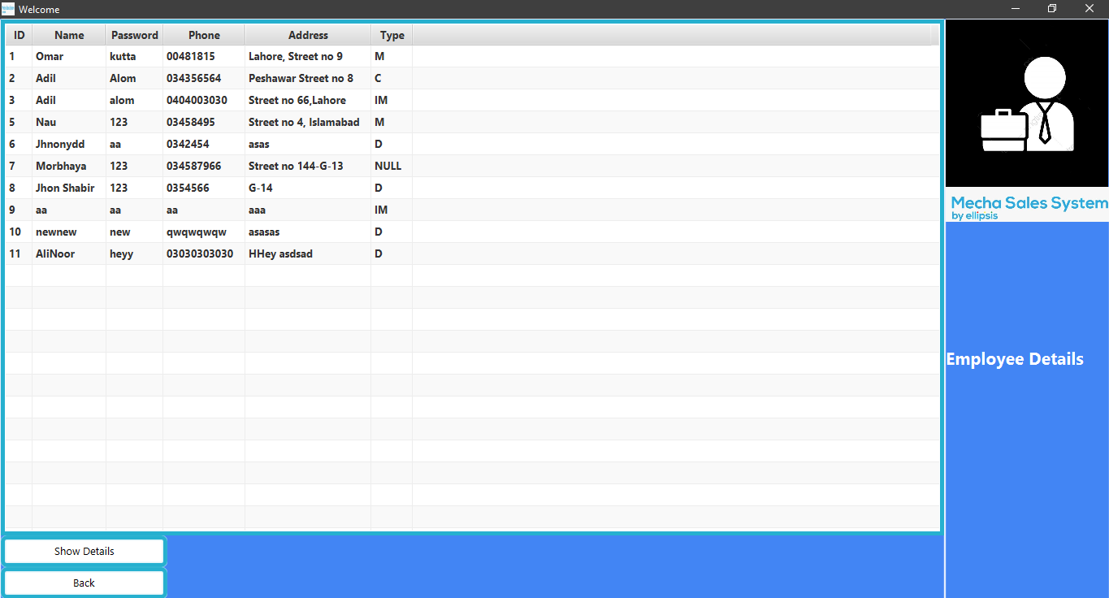

Inventory Manager UI:

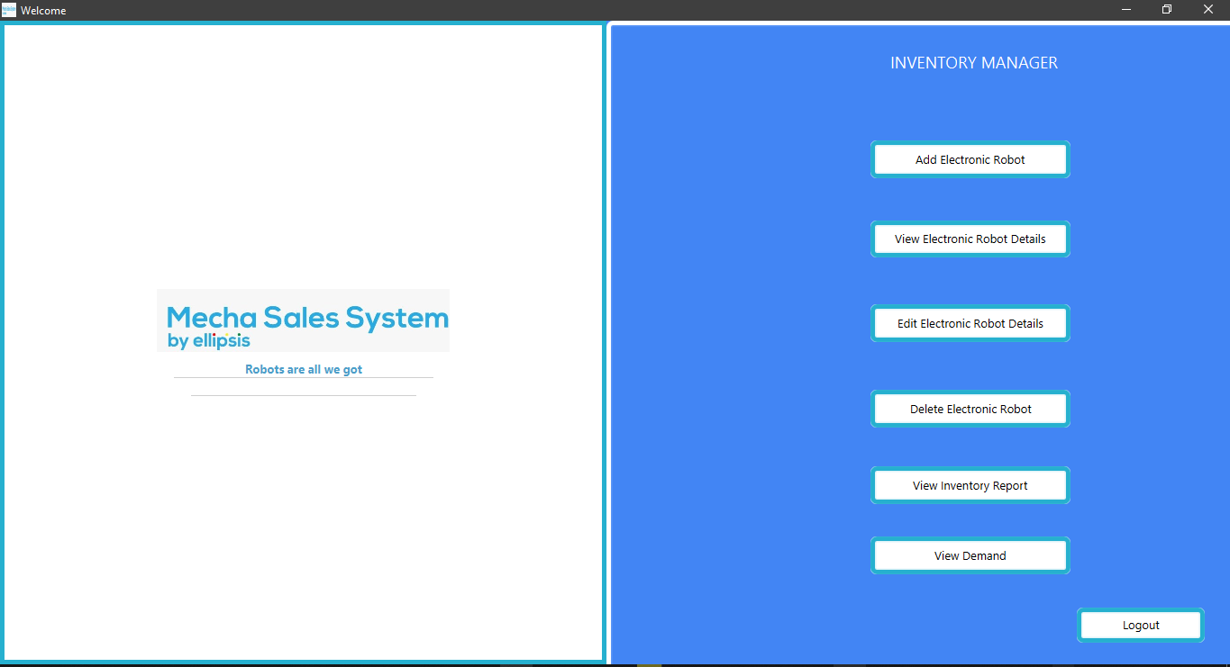

Add Electronic Robots UI:

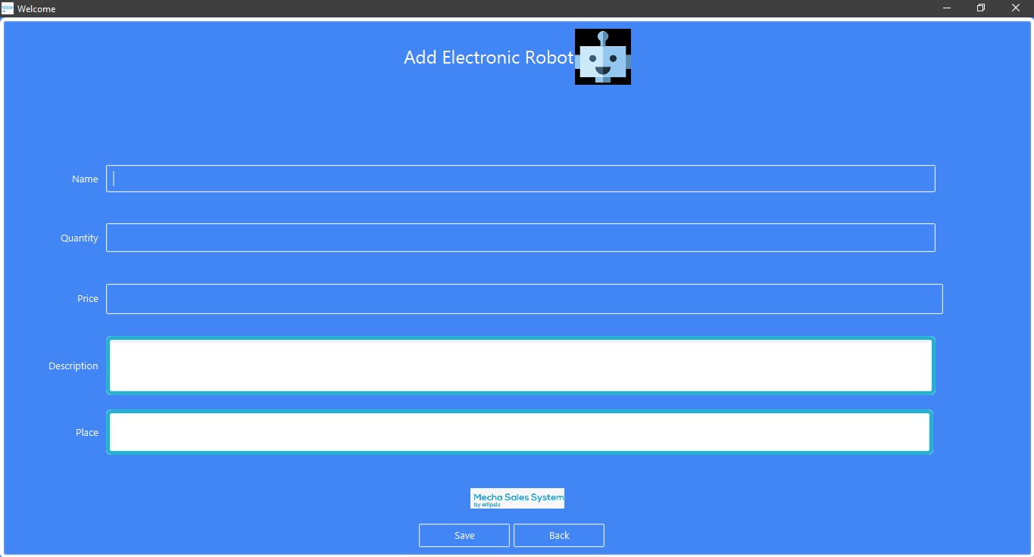

Edit E Robot Description UI:

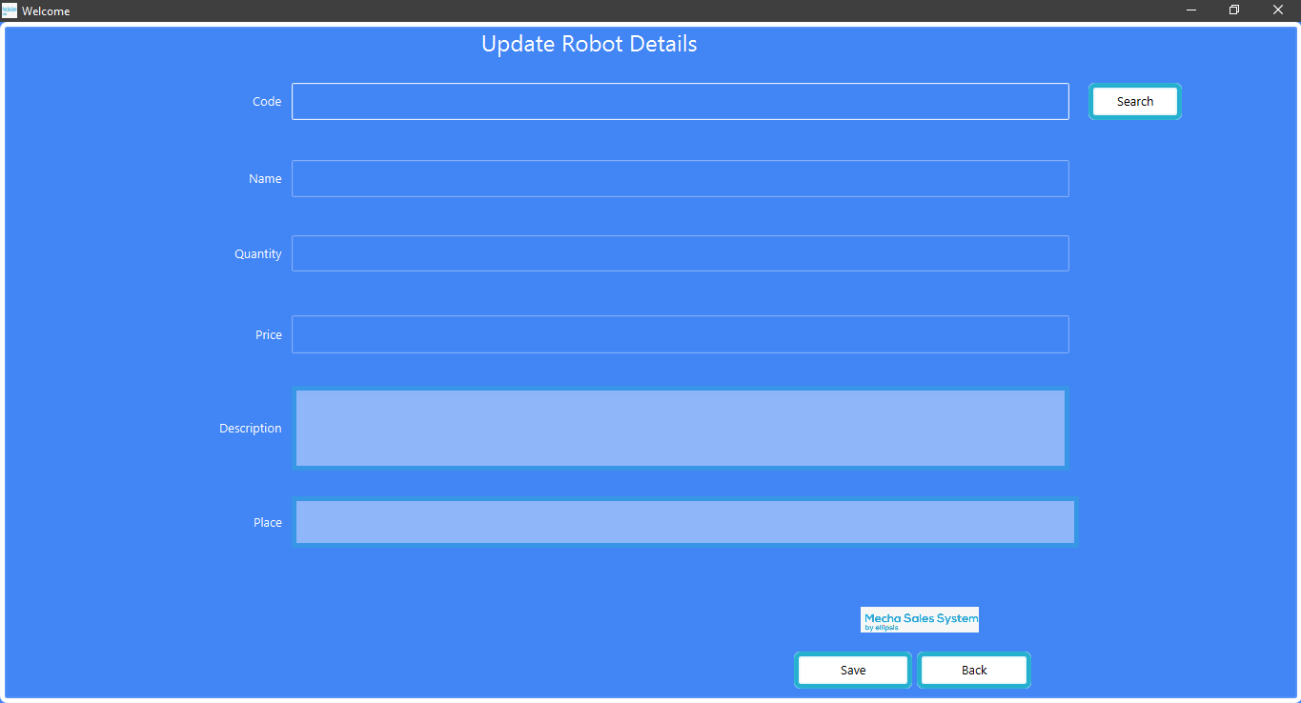

View Electronic Robot Details:

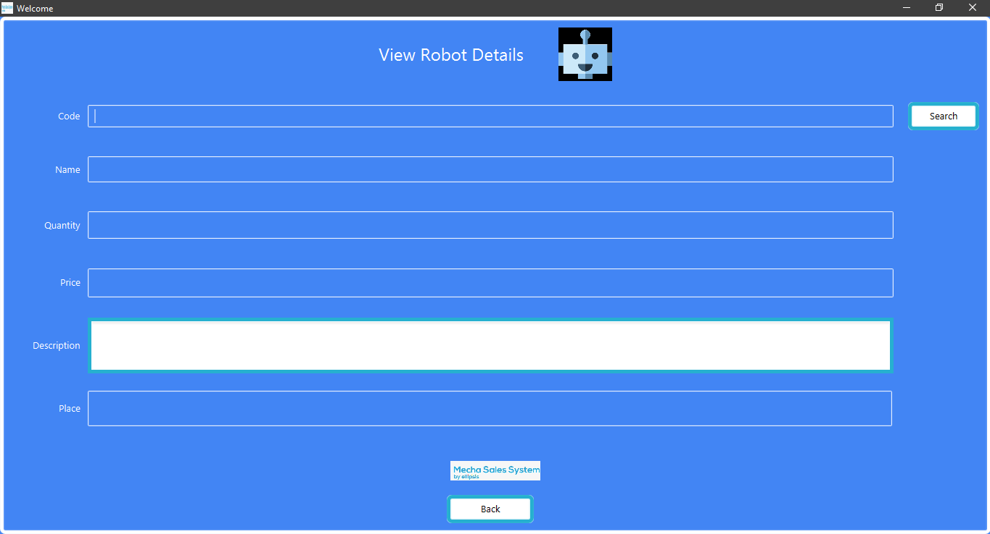

Delete E Robot Details:

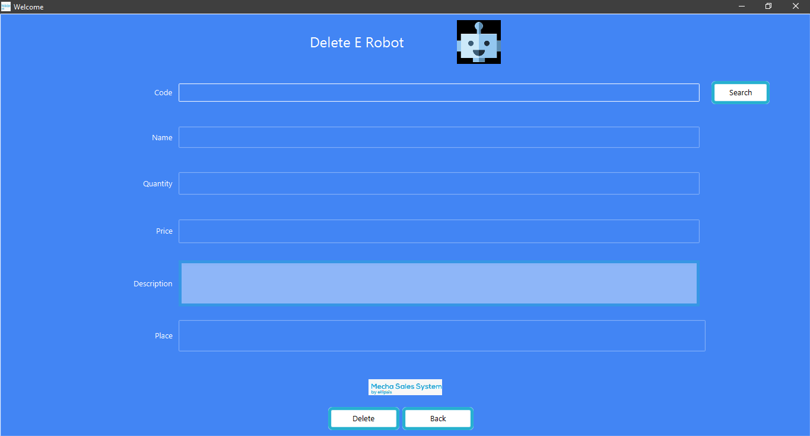

Inventory Report UI:

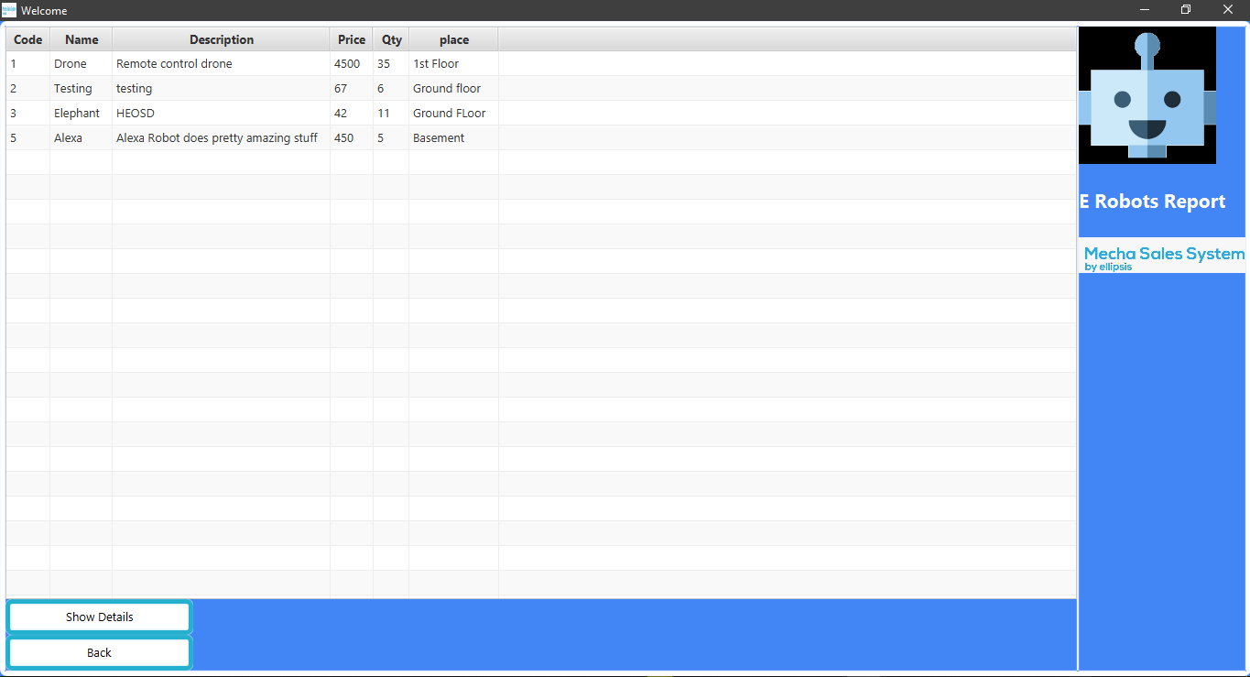

## Tested UI Screen Shots

Test Case 1: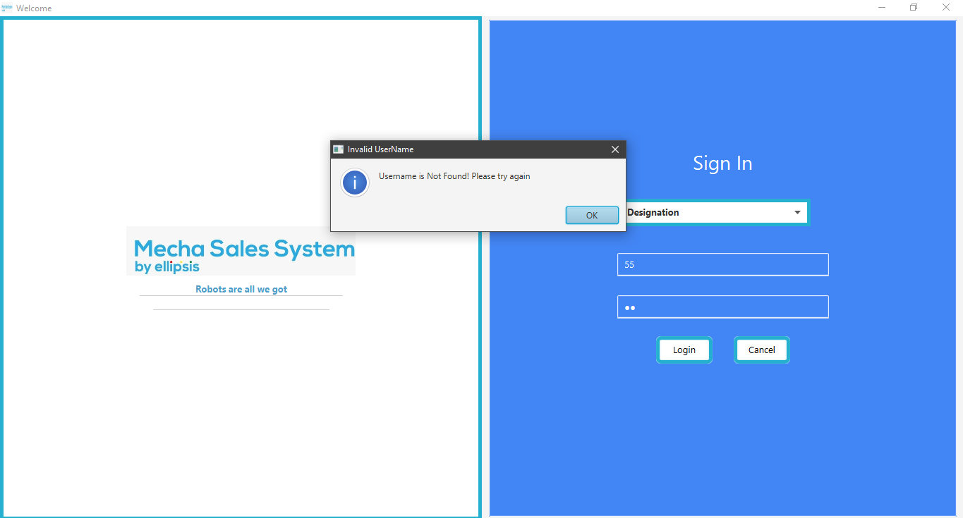

Test Case 2:

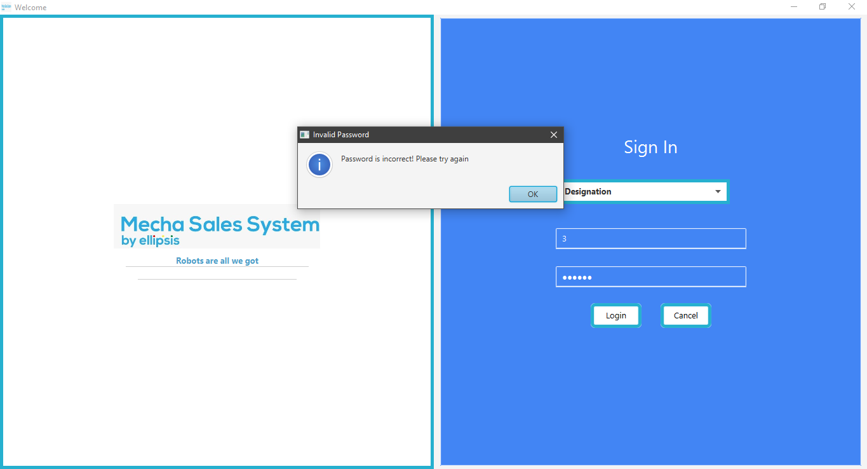

Test Case 3:

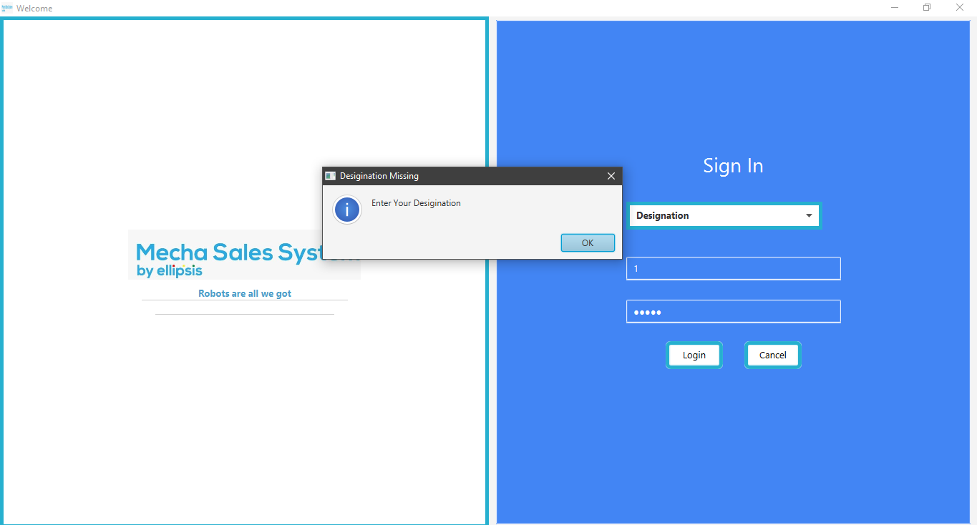

Test Case 4: 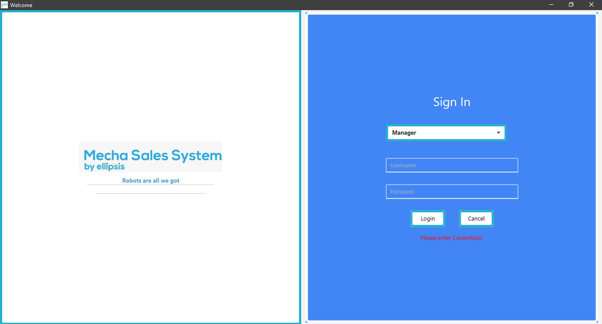

Test Case 5: 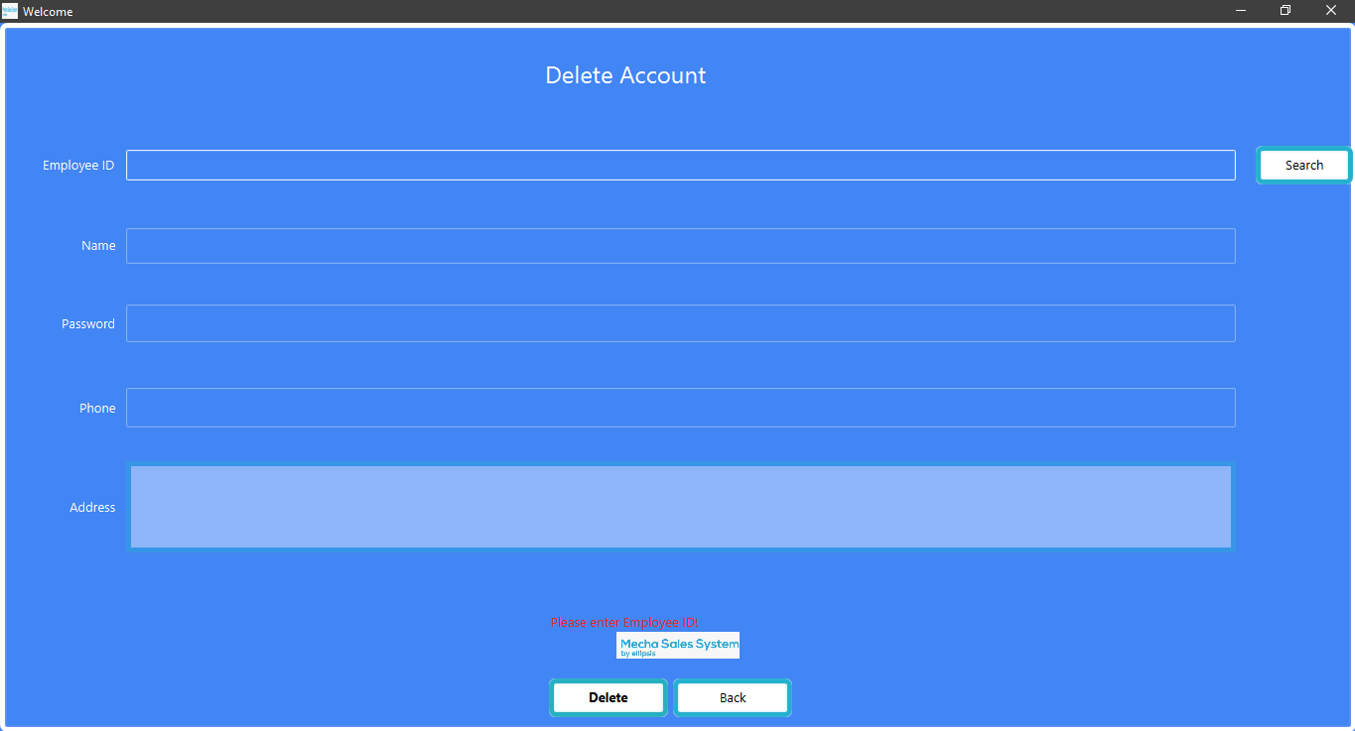

Test Case 6:

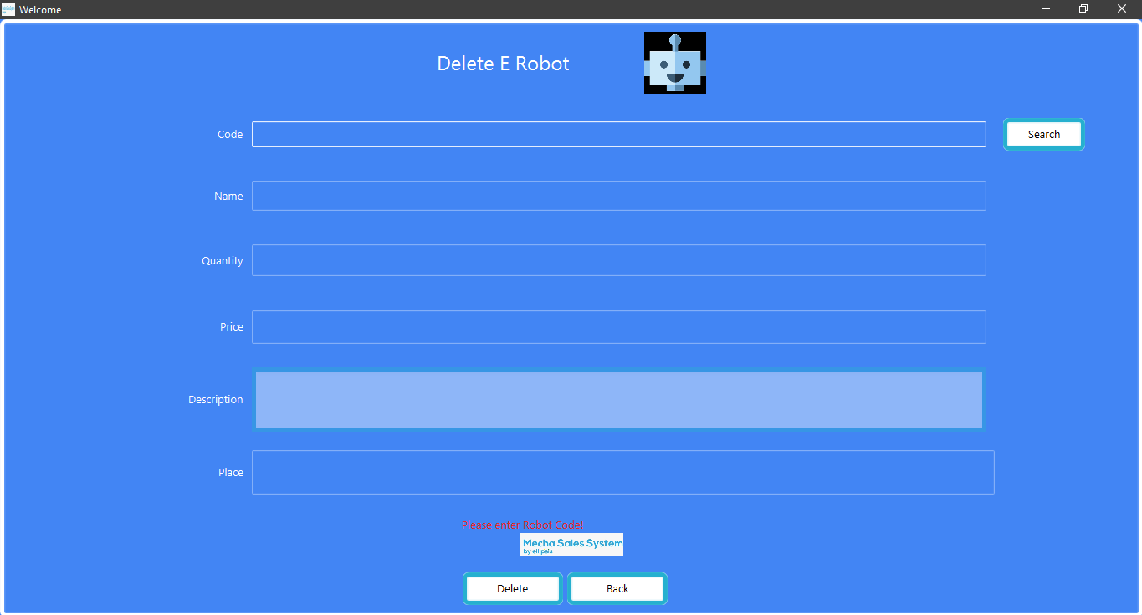

## Trello Screen Shots

Starting With Sprint Backlog:

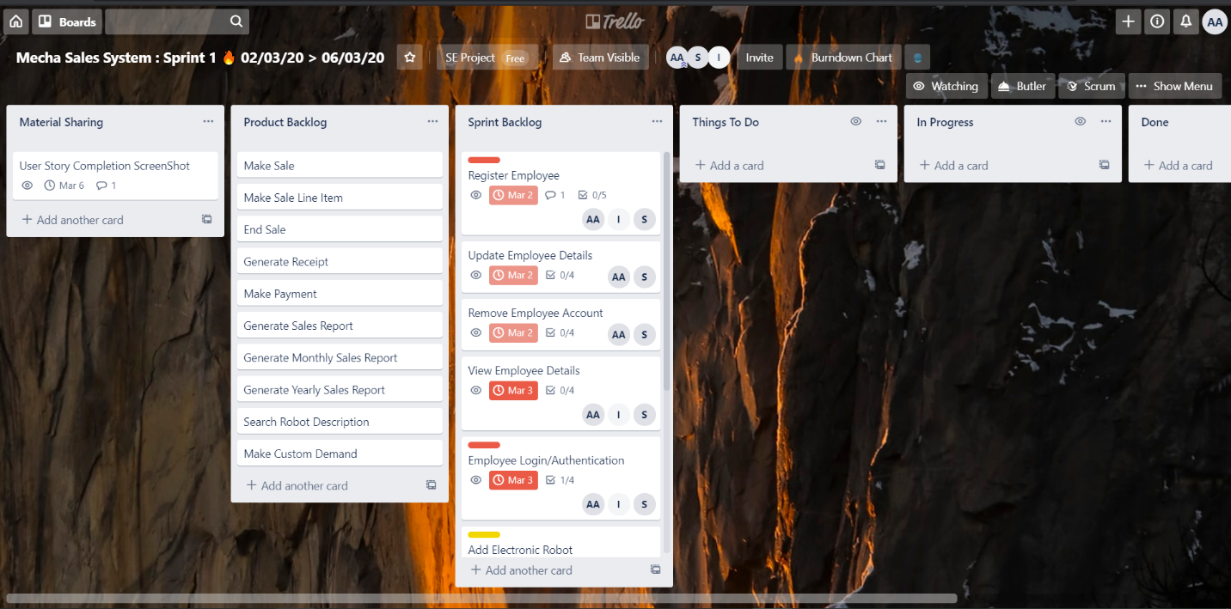

To Do:

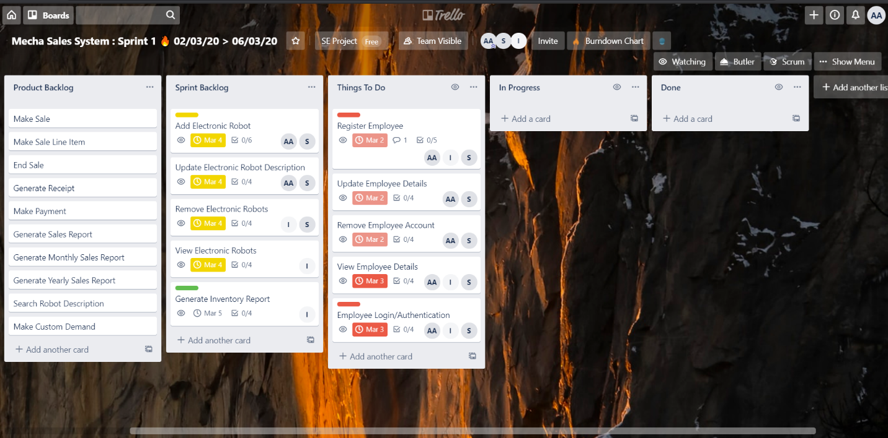

In Progress Tasks:

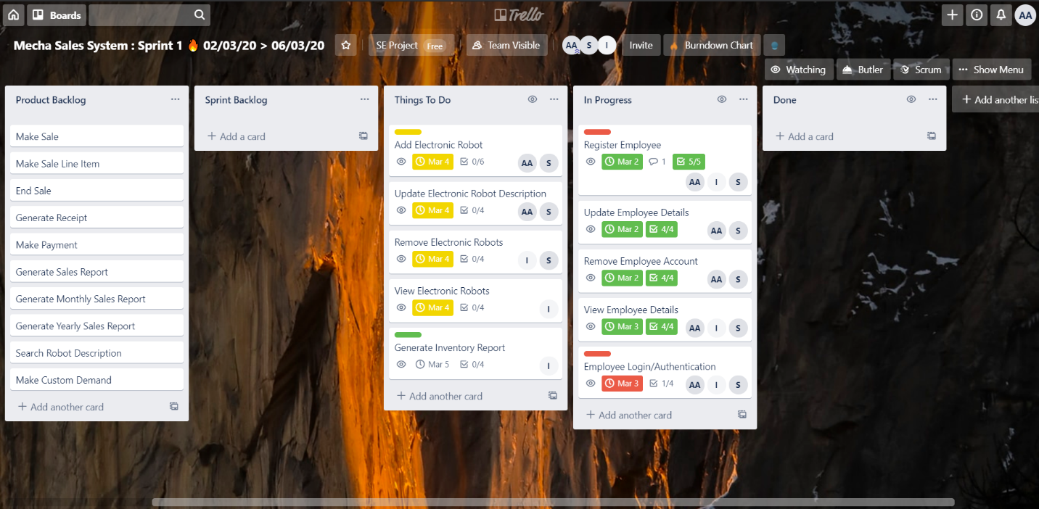

Half Progress Completed:

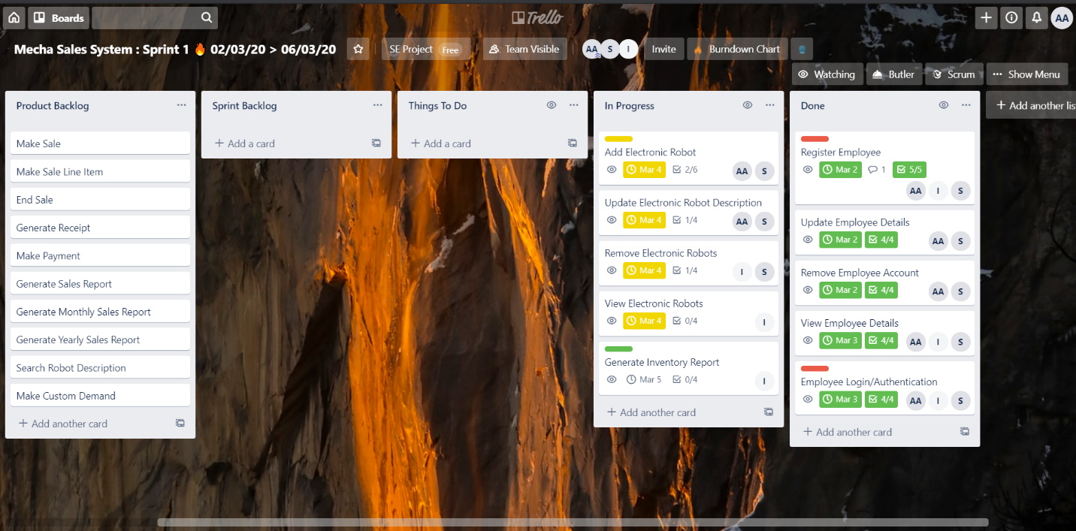

Sprint 1 Completion:

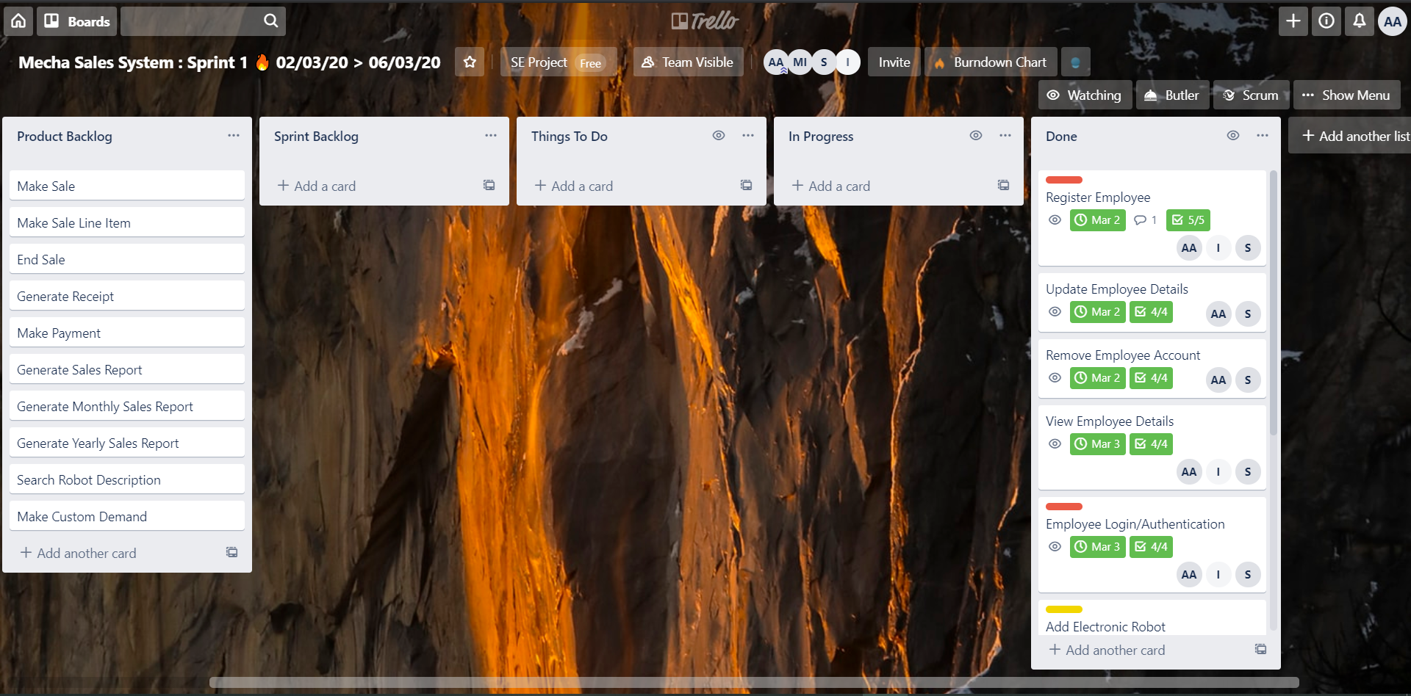

Burn Down Chart:

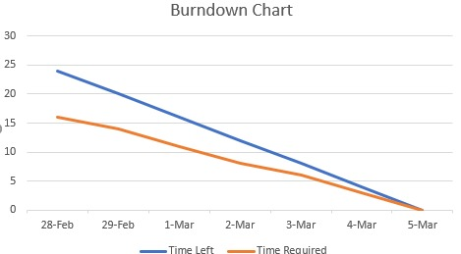

**Sprint 1 Plan**

|  |  |  |  |  |  |  |  |  |  |
| --- | --- | --- | --- | --- | --- | --- | --- | --- | --- |
| **Sr. No** | **Task** | **Total Hours** | **Hours Spent** | | | | | | |
| D1 | D2 | D3 | D4 | D5 | D6 | D7 |
| 1. | Register Employee | 3 | 2 | 1 |  |  |  |  |  |
| 2. | Update Employee Details | 2 |  |  | 2 |  |  |  |  |
| 3. | Delete Employee Account | 1 |  |  | 2 |  |  |  |  |
| 4. | View Employee Details | 1 |  |  |  | 1 |  |  |  |
| 5. | Employee Login/Authentication | 2 |  |  |  | 2 |  |  |  |
| 6. | Add Electronic Robot | 3 |  |  |  | 1 | 2 |  |  |
| 7 | Update Electronic Robot Description | 2 |  |  |  |  | 1 |  |  |
| 8 | Remove Electronic robots | 1 |  |  |  |  | 1 |  |  |
| 9 | View electronic robots Details | 1 |  |  |  |  | 1 |  |  |
| 10 | Generate Inventory Report | 3 |  |  |  |  |  | 3 |  |